Introduction to Bayesian Data Analysis

Homework 3

104502518 資工4A 劉冠聲

This homework assignment is due by midnight of 11/5. Please submit a hard copy of your homework to 工五館B322. 50% penalty will be applied if it is submitted on 11/6. No submission will be accepted after 11/6.

1. Suppose a colleague tells you she read a research report in which “there were about 50 patients and two-thirds of them survived at least one year after surgery.” Suppose you want to use this information in an informal prior for subsequent data. (You’ll get the exact numbers later.) What are the corresponding *a* and *b* shape parameters?

*Hint*: Convert from mean and concentration; why use the mean?

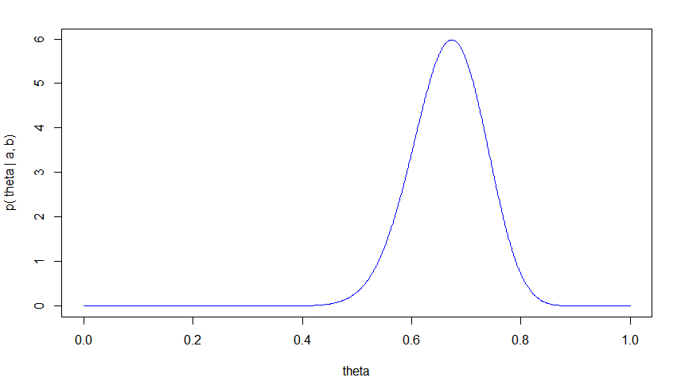

1. Suppose you are given a six-sided die, and you want to find out whether it’s biased by assessing the probability of rolling a 1-dot outcome. You know the die just came out of a brand new package from a reputable manufacturer, so you believe that the most probable probability of a 1-dot outcome is 1/6. Suppose it would take 50 rolls to begin to sway you from your prior belief that the die is fair. What are the corresponding *a* and *b* shape parameters?   
   *Hint*: Convert from mode and concentration; why use the mode?

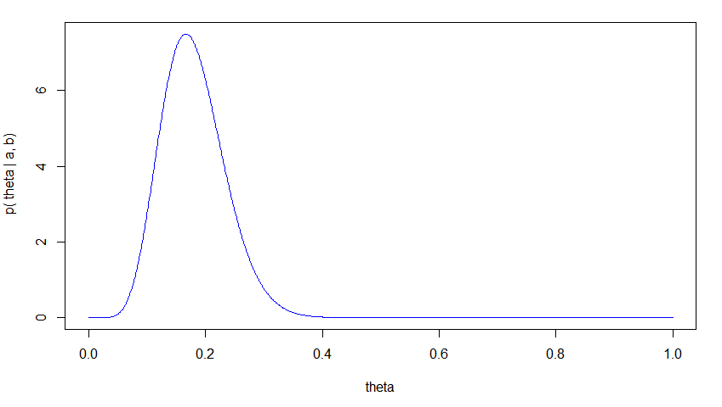

1. For all these cases, suppose the data show 63 heads in 97 flips.
   1. Suppose the prior is beta(theta|a=0.01,b=0.01), which is (approximately) the so-called Haldane prior. What is mode and 95% HDI of the posterior distribution? Show the result graphically.   
      *Hint*: Use BernBeta.R.

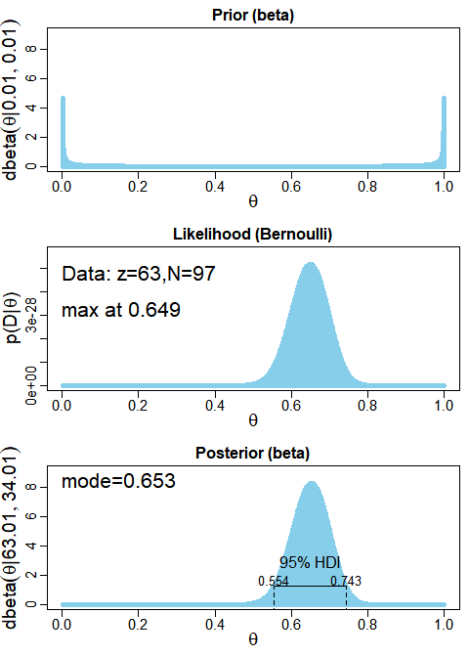

* 1. Suppose the prior is beta(theta|a=1,b=1), which is uniform. What is mode and 95% HDI of the posterior distribution? Show the result graphically.   
     *Hint*: Use BernBeta.R.

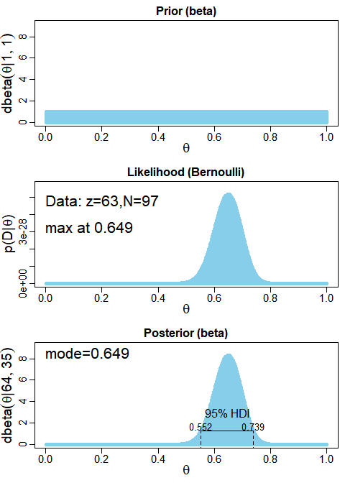

* 1. Suppose the prior is beta(theta|a=2,b=4), which is gently biased toward tails. What is mode and 95% HDI of the posterior distribution? Show the result graphically.   
     *Hint*: Use BernBeta.R.

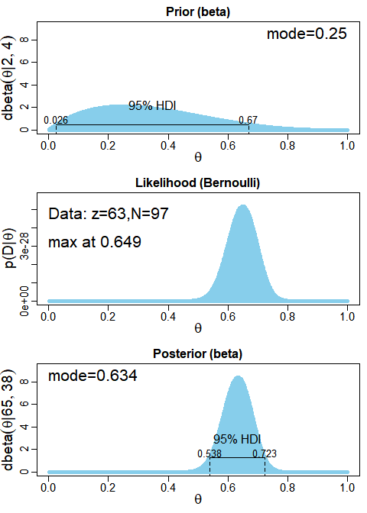

* 1. Is there much difference in the posterior distributions (modes and HDI’s) across the different priors?   
     *Hint*: Seeing that various broad priors (all beta distributions) yield similar posterior distributions for moderately large data.